1. Give a biological example of passive diffusion, facilitated diffusion, and active transport.

*Using examples we discussed in class, oxygen and water can passively diffuse across the membrane, glucose can pass through via transporters, and Na and K are transported against their gradients by active transport. Other well-described examples would be acceptable.*

1. A mutation in an ion channel has increased flux twofold. Using Fick’s law, what property of the pore has probably changed?

*For Fick’s law, the rate of solute flux ΔQs/Δt=Ds x A x ΔCs/Δx, where Ds is the diffusion coefficient, A is the area through which diffusion is occurring, and ΔCs/Δx is the concentration gradient. The concentration gradient will not likely be changed, so either Ds will change or the area of the pore will change.*

1. A membrane is permeable only to water. It is placed in a solution with 150 mM KCl inside and 15 mM KCl outside. What happens?

*In this case, inside the membrane is hypotonic and water will flow in to balance the concentration.*

1. From the question above, what is the equilibrium potential if the membrane is permeable only to Cl-? To K+? to both?

*We can compute the equilibrium potential from the Nernst equation Eion=-(60/z)*log10[Cin/Cout]. Note that this is the same as Eion=(60/z)*log10[Cout/Cin].  
z=-1 for Cl-, so ECl=-(60/-1)*log10(150/15)=60*log10(10)=60*1=+60 mV.   
In a typical cell, there is typically ~150 mM extracellular NaCl and  intracellular [Cl-]~10-15 mM (KCl is not normally found at high concentrations in the cell), so ECl is about -60 to -70 mV.   
For K+, z=1, so EK=-(60/+1)*log10(150/15)=-60*log10(10)=-60*1=-60 mV. so EK in this example is -60 mV.  In a typical cell, EK is closer to -90 mV.   
If the cell is permeable to both, the combined reversal potential would depend on the relative permeabilities of potassium and chloride.*

1. In ion channels, what is the name of the region that determines ion permeability?

*It is called the selectivity filter.*

1. In ion channels, what are two common gating mechanisms that control whether a channel is open or closed?

*Membrane voltage, ligand binding, pH, and mechanical deformation are all potential mechanisms. For example, Shaker K+ and action potential K+ channels are voltage-gated channels, such that depolarization of the membrane will open the channel.*



1. Describe the cycle of events that occur if the membrane potential changes according to the voltage step shown above for the voltage-dependent sodium channel used to generate action potentials.

*The sodium channel starts out closed at this membrane potential. Depolarization will cause the channel to open. Continued depolarization will cause the channel to inactivate, meaning that the channel is in an open conformation, but entry into the cytoplasm is blocked. Return to -80 mV removes the inactivation block and allows the channel to return to its original closed conformation.*

1. What initially changes the channel conformation for the Na/K pump?

*ATP hydrolysis changes the channel conformation.*

1. Why do K+ ions dissociate from the Na/K pump?

*After dephosphorylation, the channel returns to the E1 conformation, lowering the affinity of the pump for K+, so they dissociate.*

1. Give one biological example of a symport and one example of an antiport.

*The Na/glucose transport is an example of a symport and the Na/K exchange or the H/K exchange is an example of an antiport*

1. Which part of the neuron ends in a presynaptic terminal? Which part contains postsynaptic receptors? *The axon ends in a presynaptic terminal. The dendrite contains postsynaptic receptors.*

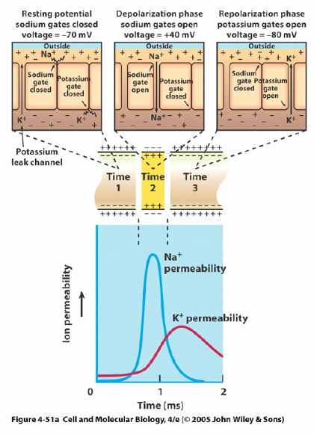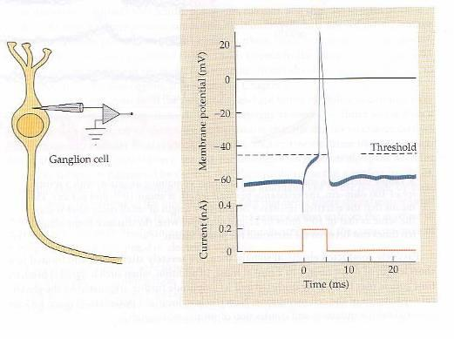

1. Draw a voltage versus time plot for an action potential elicited in response to current injection through a microelectrode. Below that, plot the changes in the Na+ and K+ channel conductances.

*An action potential in response to current injection into the cell is shown on the left. Conductance changes associated with the action potential are shown on the right.*

1. What specialization allows action potentials to travel long distances (1 meter in our nerves to our limbs) rapidly and with minimal energy expenditure?

*Myelination of axons and clustering of sodium and potassium channels at the nodes of Ranvier.*

1. From the generation of an action potential in the presynaptic neuron, describe how an excitatory postsynaptic potential is generated in the postsynaptic neuron.
2. *Presynaptic axon terminal is depolarized by the action potential.*
3. *Calcium channels in the axon terminal are opened by depolarization*
4. *Calcium ions flow into the neuron through the open channels.*
5. *Calcium induces synaptic vesicles to fuse with the presynaptic membrane.*
6. *Neurotransmitter molecules (glutamate, in this case) are released into the synaptic cleft and bind with postsynaptic receptors.*
7. *Binding of neurotransmitter (glutamate) causes channels to open in the neuron, producing a depolarization of the neuron, which is an excitatory postsynaptic potential (EPSP)*.
8. Give a biological example of passive diffusion, facilitated diffusion, and active transport.

*Oops, same as 2 above*

|  |  |
| --- | --- |
| Pathway 1 | Pathway 2 |
| *D* | *B* |
| *F* | *J* |
| *I* | *H* |
| *E* | *C* |
| *A* | *G* |

1. A. cAMP dissociates PKA catalytic subunit

B. insulin binds to insulin receptor

C. docking protein binds to receptor

D. glucagon binds to receptor

E. adenylyl cyclase produces cAMP

F. GTP displaces GDP on G-protein

G. PIP3 is formed

H. transautophosphorylation

I. GTP-alpha activates its effector

J. receptor dimerization

Steps for two pathways are shown above. Place the steps A through J in the proper pathway and in the proper order, with the top step as the first step in the sequence.

1. What allows water to pass in and out of cells more rapidly than diffusion across the membrane? Aquaporin channels
2. A single ligand binding to a G-protein coupled receptor can lead to significant signal amplification in the cell. Describe one way that the intracellular signal is amplified in G-protein coupled receptor pathways.
3. *Binding of a single ligand molecule can activate many G-proteins as long as the G-protein coupled receptor remains in a bound conformation.*
4. *A single GTP-alpha can produce many second messenger (cAMP) molecules as long as it remains associated with the effector, adenylyl cyclase.*
5. You awake from studying for Bio 230 to find that the exam starts in three minutes, so you sprint out the door. Epinephrine stimulates glycogen breakdown to glucose. How is glycogen synthesis inhibited by epinephrine After the exam, you eat three donuts and are ready to nap. How is glycogen synthesis stimulated by insulin ?

*PKA inhibits glycogen synthase.*

*Insulin stimulates production of PIP3 by PI3K. PI3K activates PDK and PKB. This ultimately leads to the inhibition of GSK3 (glycogen synthase kinase 3), which inhibits glycogen synthase. Deactivation of the inhibitory GSK3 allows glycogen synthase to operate and produce glycogen.*

1. Describe one example of divergence in signaling pathways and one example of convergence in signaling pathways

*There are multiple possibilities for each of these. For example, phospholipase C (PLC) causes divergence by making diacylglycerol (DAG) and inositol triphosphate (IP3), whose paths diverge. For convergence, one example is that multiple pathways converge on Ras signaling and enter the MAP kinase cascade. The point of convergence is that two or more different pathways converge on one molecule after which the path is the same. The point of divergence is that a single pathway can split into two or more pathways (e.g. PIP3 and Ras-GTP creation by insulin receptor binding. For crosstalk, there are many potential examples. One recent example would be crosstalk (shared usage) for ATP in actin polymerization and myosin motion.*

1. Describe how glycogen synthase activity is regulated by the pathways for glycogen breakdown versus glycogen synthesis.

*Glycogen synthase is inactivated by phosphorylation.*

*PKA phosphorylates glycogen synthase and inhibits it.*

*GSK3 (glycogen synthase kinase 3) phosphorylates glycogen synthase and inhibits it.*

*Additional description of PIP3 activating PDK1 and PKB to phosphorylate PKB and inactivate it. PKB phosphorylates GSK3 to inhibit it.*

1. Name two functions of the cytoskeleton and give one example of when this function is used. *Cell movement, as in a neuronal growth cone, and intracellular tracks, as when transporting organelles along mitochondria.*
2. Describe or draw and label the structure of a microtubule. Show how to distinguish the plus and minus ends.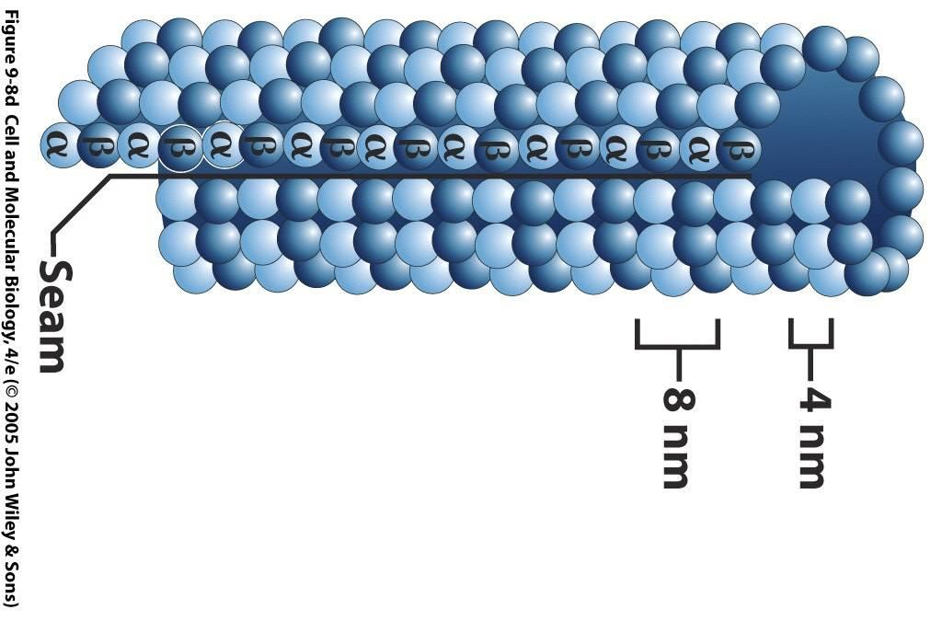

*The right is the + end and the left is the minus end. Beta subunits form the edge of the + end. Also, GTP and GDP will be actively exchanging at the + end only.*

1. In the diagram to the left, what has probably been added to the cell for the blue line? For the dashed line, would you expect the [GTP] to be high or low? 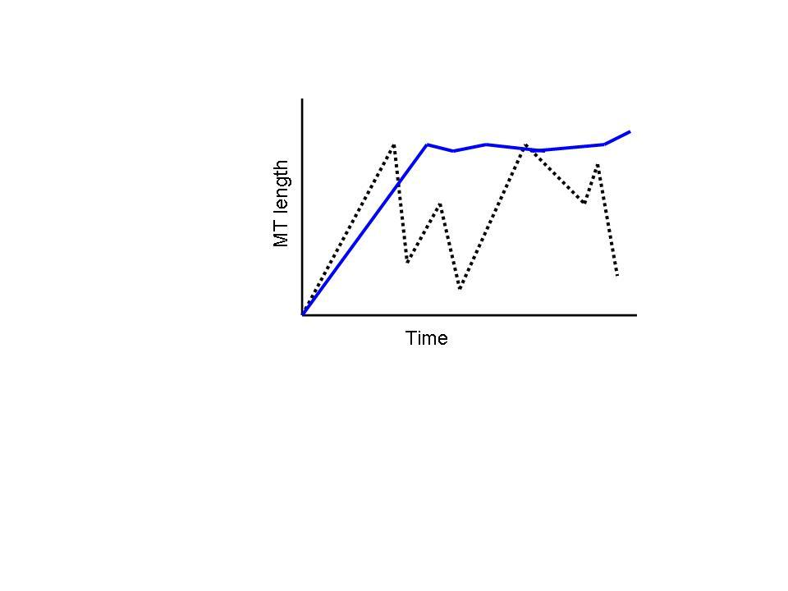

*A microtubule associated protein (MAP) has been added to stabilize the microtubule for the blue line.* *While it is somewhat indeterminate without a reference point, the multiple catastrophic shrinkage events generally indicate a low [GTP], whereas a high [GTP] will usually result in mostly elongation of the microtubules.*

1. What is the force generating segment in kinesin, dynein, and myosin?

*The head.*

1. What is one way to control the rate of kinesin movement along a microtubule? What will happen if a non-hydrolyzable form of ATP is introduced into a kinesin microtubule cell free system?

*[ATP] will control the rate of kinesin movement. If ATP can only bind but not hydrolyze to ADP + Pi, then the kinesin heads will be stuck to the microtubules*

1. What are two similarities and two differences between tubulin protofilaments and actin microfilaments? *Both have plus and minus ends. Both have faster growth on the + ends and slower on the – ends. Actin uses ATP and tubulin uses GTP to promote polymerization. The secondary structures are quite different. Tubulin subunits form single chains called protofilaments and then cylinders of ~13 protofilaments, whereas actin filaments form double helices.*
2. What is the structure to the left and what is its function? Label the parts indicated by the lines on the bottom. 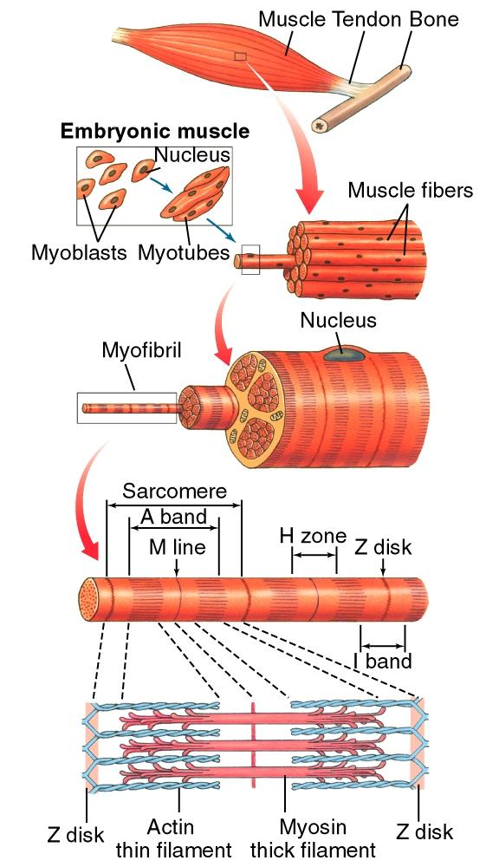

*This is a sarcomere, the basic component of skeletal muscle. The Z lines (Z disks) are at each end. The second line from left are the thin filaments, made of actin. The line pointing to the red is pointing to the thick filaments (myosin).*

1. How are microtubules able to be generated initially, meaning, what facilitates their initial formation (nucleation)?

*Gamma tubulin and in many cases, a ring complex (microtubule organizing centers)*

1. What does ATP binding (as opposed to hydrolysis) do in the motor cycles of both kinesin and dynein? *It causes the major conformational changes that move the motor heads.*
2. Name two factors that determine transition temperature. *Number of unsaturated bonds and fatty acid chain length?*
3. How might you test that a protein is associated with a lipid raft*? Lipid raft membranes have a different composition than standard membranes. If those membranes can be isolated or identified, an antibody to the protein would determine whether the protein is colocalized specifically in the lipid raft regions.*
4. If you wanted to measure membrane fluidity, what is one way that you could do it? *FRAP*
5. How would you determine whether a portion of a protein is extracellular or cytoplasmic? *Bathe some cells in trypsin and some not. Isolate protein and run a gel. Determine which bands on gel have shifted*.
6. What do astrocytes and oligodendrocytes do? Astrocytes regulate neuronal, energetic, nutritional and extracellular environment over long time scales (> seconds)
7. If the measured whole-cell potassium current is 2 nA, the membrane potential is voltage clamped at 0 mV, and the reversal potential for potassium is -90 mV, what is the whole-cell potassium conductance? (units are Siemens = 1/Ohms).

*IK=gK(Vmem-EK). 2x10-9 A = gK(0-(-9x10-2V)). gK=2x10-9 A/9x10-2= 2.22x10-8 S (22.2 nS)*

1. Describe what a neuron’s refractory period is. *The minimum interval at which the neuron can fire another action potential.*